**Experiment 3**

Valiveti Manikanta Bhuvanesh

19BCD7088

AIM: Visualizing data using R with different type of graphs and charts

**4.Line Graph**

**Code:**

x <-c(1:5);

y <-c(1:5);

par(pch=22, col="red")

par(mfrow=c(2,4))

opts=c("p","l","o","b","c","s","S","h")

for(i in 1:length(opts)) {

heading = paste("type=",opts[i])

plot(x, y,type=opts[i], main=heading)

}

**Output:**

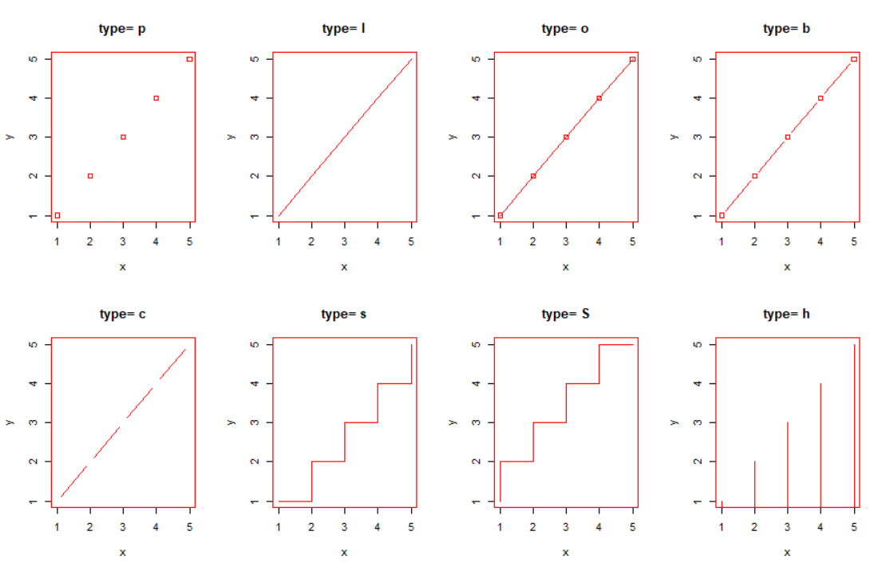

**5.Bar Plot**

**Code:**

H<-c(7,12,28,3,41)

M<-c("Mar","Apr", "May","Jun","Jul")

barplot(H,names.arg=M,xlab="Month",ylab="Revenue",col="blue", main="Revenue chart",border="red")

Marks<-c(23,45,65,76,89)

names<-c('a','b','c','d','e')

barplot(Marks,names.arg=names,xlab="Names",ylab="Marks",col="red", main="Marks chart",border="yellow")

height<-c(4.5,5.3,5.8,6.1,5.5)

barplot(height,names.arg=names,xlab="Names",ylab="Height",col="orange", main="Height chart",border="black")

**Output:**

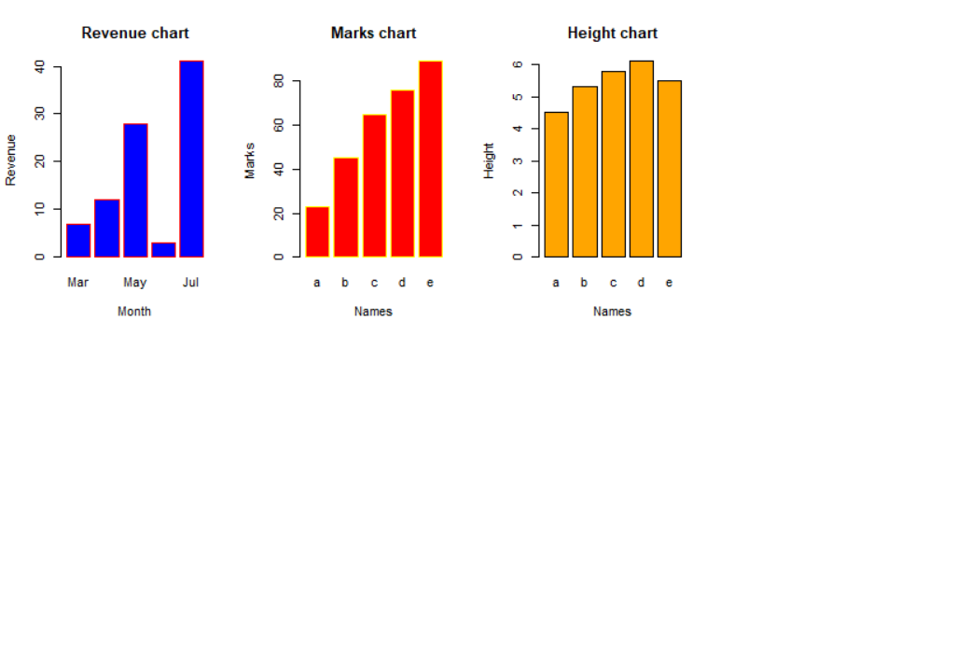

**Code:**

colors= c("green","orange","brown")

months <-c("Mar","Apr","May","Jun","Jul")

regions <-c("East","West","North")

Values <- matrix(c(2,9,3,11,9,4,8,7,3,12,5,2,8,10,11), nrow = 3, ncol = 5,byrow = TRUE)

barplot(Values, main="total revenue", names.arg = months, xlab = "month", ylab = "revenue", col = colors)

legend("topleft", regions, cex = 1.3, fill = colors)

**Output:**

